Welcome to our home page

Within this site you will find all the information you require to ride a motorcycle legally on the road.

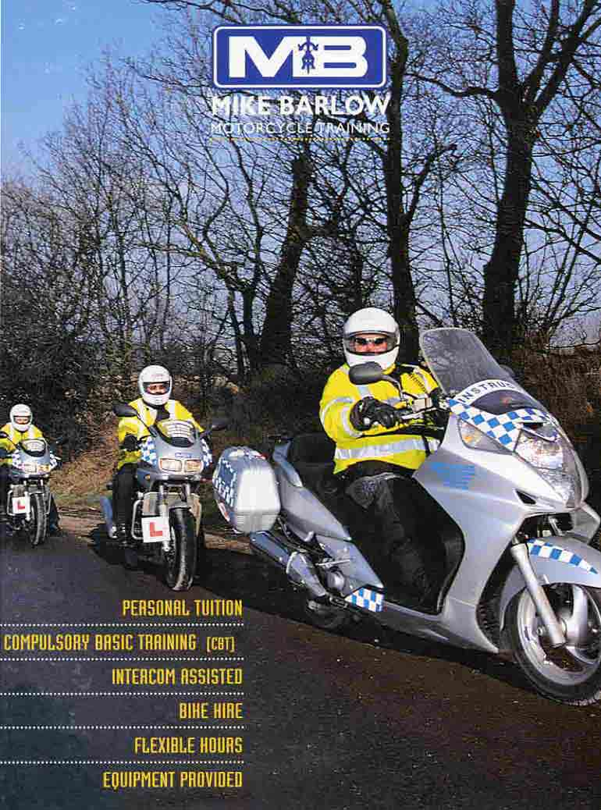 | Mike Barlow Motorcycle Training is situated on the outskirts of Chesterfield, Derbyshire. We have a team of experienced instructors who will help to get you through your riding test. We instruct on all courses from CBT through to Direct Access. You can be sure you will receive some of the best instruction available.  Please browse the web site and feel free to contact us should you require any furhter information or to book a course.  Many thanks, Mike Barlow.

